**AP LAB – SESSION 1**

**LAB 1:**

QUESTION – 1:

#odd from first and even from second list

first = list(input("Enter first list: ").split())

second = list(input("Enter second list: ").split())

result = list()

for i in first :

if int(i) % 2 == 1 :

result.append(i)

for i in second :

if int(i) % 2 == 0 :

result.append(i)

print(result)

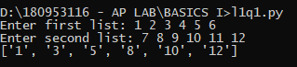

QUESTION 2:

#DISPLAY THE GIVEN PATTERN

count = 1

for i in range(1,6) :

for j in range(1,i+1) :

print(count, end=" ")

count+=1

print("")

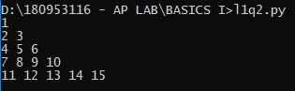

QUESTION 3:

#OPERATIONS ON STRINGS

n = int(input("Enter a number 'n': "))

s_list = list()

for i in range(n) :

s_list.append(input("Enter the string: "))

count = 0

for s in s_list :

if s[0]==s[-1] and len(s) > 1 :

count+=1

print("Count of strings that start and end with same character and have more than 2 characters is: ", count)

print("Strings that have odd length are: ")

for s in s_list :

if len(s) %2 == 1 :

print(s)

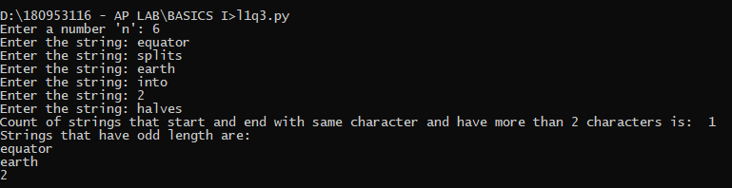

**LAB 2:**

QUESTION – 1:

#Count number of words in a sentence using dictionaries

s = input("Enter a string: ")

s_list = list(s.split())

d = dict()

for item in s_list :

if item in d.keys() :

d[item]+=1

else :

d[item]=1

count = 0

for pair in d :

count+=d[pair]

print("Number of words = ",count)



QUESTION – 2:

#Operation on matrices using dictionaries

ar, ac = input("Enter order of first matrix: ").split()

br, bc = input("Enter order of second matrix: ").split()

if ar == br and ac == bc :

ad = dict()

bd = dict()

result = list()

print("Input matrix A: ")

for i in range(int(ar)) :

r =[int(j) for j in input("Enter a row: ").split()]

for ele in r :

if ele == 0 :

pass

else :

ad[str(int(i)) + str(r.index(ele))] = int(ele)

print("Input matrix B: ")

for i in range(int(br)) :

r =[int(j) for j in input("Enter a row: ").split()]

for ele in r :

if ele == 0 :

pass

else :

bd[str(int(i)) + str(r.index(ele))] = int(ele)

for i in range(int(ar)) :

row = list()

for j in range(int(ac)) :

ind = str(int(i)) + str(int(j))

if ind in ad and ind in bd :

row.append(int(ad[ind]) + int(bd[ind]))

elif ind in ad and ind not in bd :

row.append(int(ad[ind]))

elif ind not in ad and ind in bd :

row.append(int(bd[ind]))

elif ind not in ad and ind not in bd :

row.append(int('0'))

result.append(row)

print("Addition of given two matrices: ")

for ro in result :

for ele in ro :

print(ele, end = " ")

print("")

else :

print("Orders do not match to add the matrices")

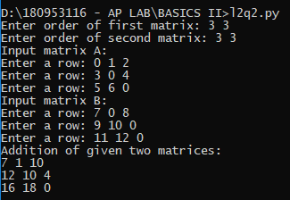

QUESTION – 3:

#Operations on dictionaries

import random

import string

print("Enter values of dictionary: (Enter'N' to end)")

inp = input("Enter a value: ")

d= dict()

while inp != 'N' :

d[random.randrange(1,100)]=inp

inp = input("Enter a value: ")

count = 0

sm = 0

for ele in d :

if d[ele].isnumeric() == True :

sm += int(d[ele])

count += 1

print("Average = ", sm/count)

result = ""

for ele in d :

if d[ele].isnumeric() == False :

result+=d[ele]

print("Concatenated String is: ", result)

search = input("Enter a value to search in the dictionary: ")

key_list = list(d.keys())

value_list = list(d.values())

if search in value_list :

print("Key is: ", key_list[value_list.index(search)])

else :

print("Search element not found")

print("Strings that contain only special characters: ")

for value in value_list :

if all(i in string.punctuation for i in value) :

print(value)

